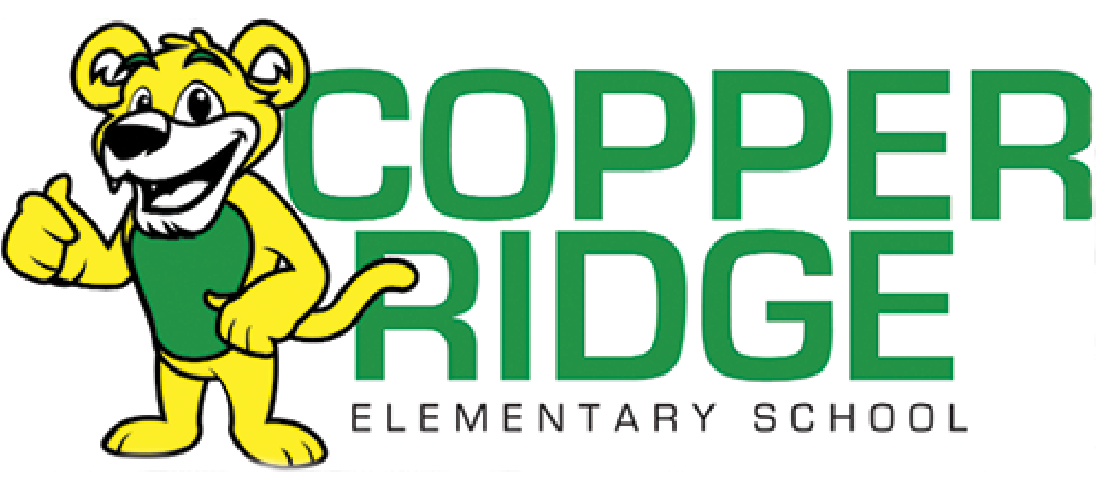

**Kindergarten Supply List**

* Large Backpack (no rolling ones)
* Plastic Pencil Box (labeled)
* Children’s Fiskar blunt metal scissors (labeled)
* 2 packs of 24 count Crayola crayons
* 2 dry erase markers
* 1 pack of washable markers
* 2 containers of playdough
* Headphones- *No earbuds (labeled)
* Water Bottle with flip-top spout (labeled) this is a newly added item

Everyone needs to send in an extra change of clothes for your child in a labeled Ziploc bag.

**Please label items/boxes with your child’s name.**

**Watch store ads for sales this summer!**